Home Farm Equine Ltd
22 Fern Road
Cropwell Bishop
Nottinghamshire
NG12 3BU
Tel: 0115 989 9411
Email: info@homefarmequine.co.uk
www.homefarmequine.co.uk

17th July 2026

VETERINARY REPORT
“Optimus Maximus”
Microchip : 953010006531548
Ex Diva De Lux- Microchip: 372141404569661
By Fruselli- Microchip: 52800321001691

DOB: 14.07.2022
Covered: 09.08.2021

I confirm the above horse was born on 14.07.2022 and the parentage is correct.

Yours sincerely,
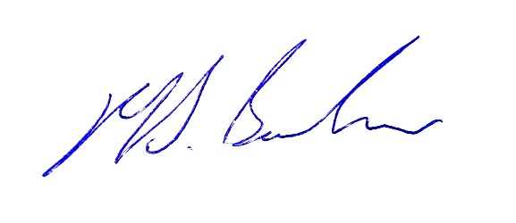

Matthew Barlow BVM&S, MRCVS
Home Farm Equine Ltd

