Home Farm Equine Ltd
22 Fern Road
Cropwell Bishop
Nottinghamshire
NG12 3BU
Tel: 0115 989 9411
Email: info@homefarmequine.co.uk
www.homefarmequine.co.uk

17th July 2026

VETERINARY REPORT
“Indiana Jones”
Microchip: 953010007798672
Ex Orchids Vienna- Microchip: 528210000876801
By Jumanji- Microchip: 826002140880741

DOB: 17.06.2025
Covered: 04.07.2024

I confirm the above horse was born on 17.06.2025 and the parentage is correct.

Yours sincerely,
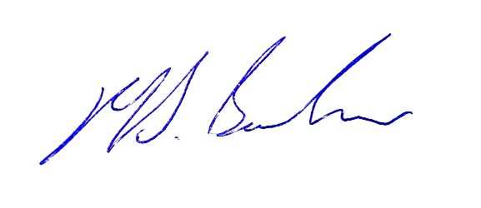

Matthew Barlow BVM&S, MRCVS
Home Farm Equine Ltd

