Home Farm Equine Ltd
22 Fern Road
Cropwell Bishop
Nottinghamshire
NG12 3BU
Tel: 0115 989 9411
Email: info@homefarmequine.co.uk
www.homefarmequine.co.uk

17th July 2026

VETERINARY REPORT
“Dragonfly Sakura”
Microchip : 953010007836718
Ex Emerald Butterfly Microchip : 37244004884880
By Jumanji Microchip: 826002140880741

DOB: 23.07.2024
Covered 20.08.2023

I confirm the above horse was born on 23.07.24 and the parentage is correct.

Yours sincerely,
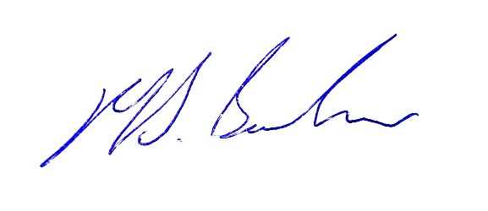

Matthew Barlow BVM&S, MRCVS
Home Farm Equine Ltd

